Sri Lanka Institute of Information

Technology



Lab Submission

Lab sheet No 10

**IT24101396**

**Ilanganthilaka S.K.**

**IT2120 - Probability and Statistics**

B.Sc. (Hons) in Information Technology

# Questions

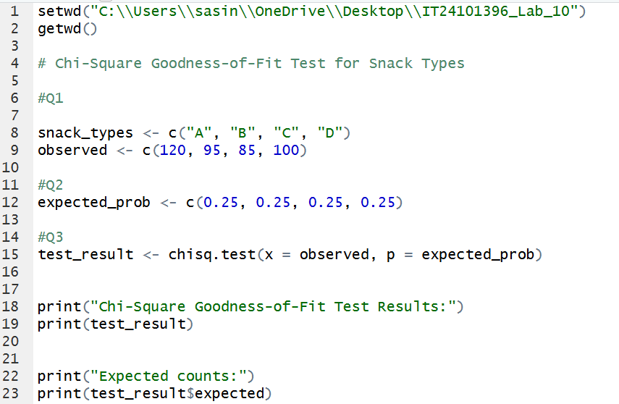

# Answers

# 

# 